9. Pothole Segmentation (Member 3)

9.1 Introduction
This section presents the pothole segmentation module developed to detect small surface potholes from enhanced road frames. The approach uses classical image processing techniques including thresholding, morphological operations, and contour analysis to isolate pothole regions from the road surface.
The goal of this module is to accurately identify potholes while minimizing false detections caused by shadows, gravel texture, and roadside elements.

9.2 Segmentation Pipeline
The implemented pipeline follows these steps:
Each stage contributes as follows:
- Grayscale conversion reduces computational complexity
- CLAHE enhances contrast in low-light and shadow regions
- Gaussian blur suppresses noise from road texture
- Thresholding extracts dark pothole regions
- Morphological operations remove small noise and fill gaps
- Contour detection identifies pothole boundaries
- Bounding boxes visualize detected potholes
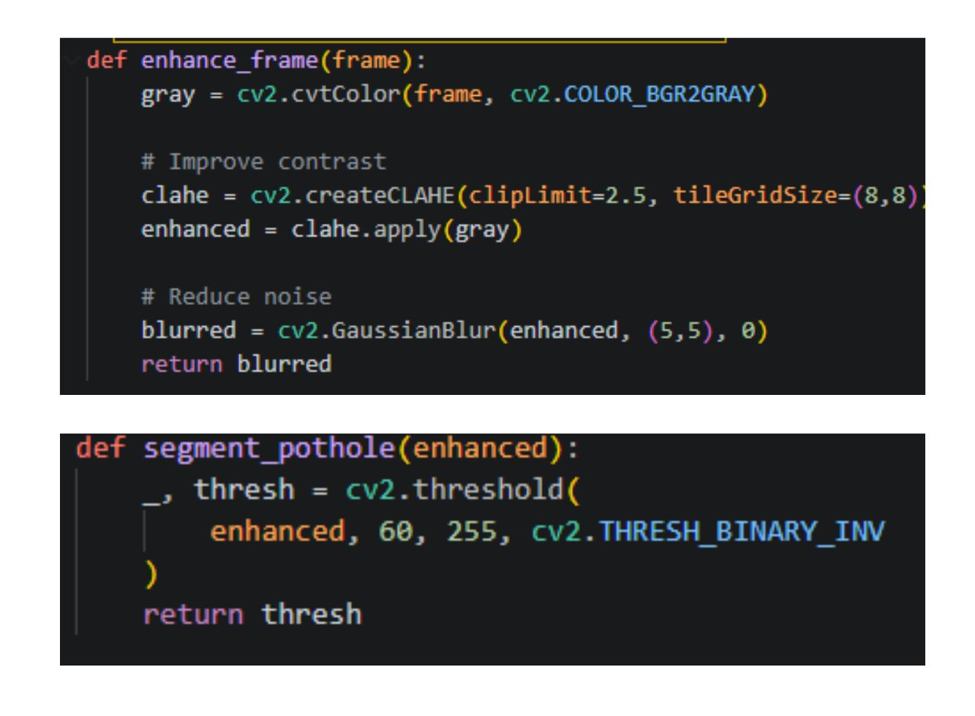
Figure 9.2.1: Implementation of image enhancement and thresholding functions

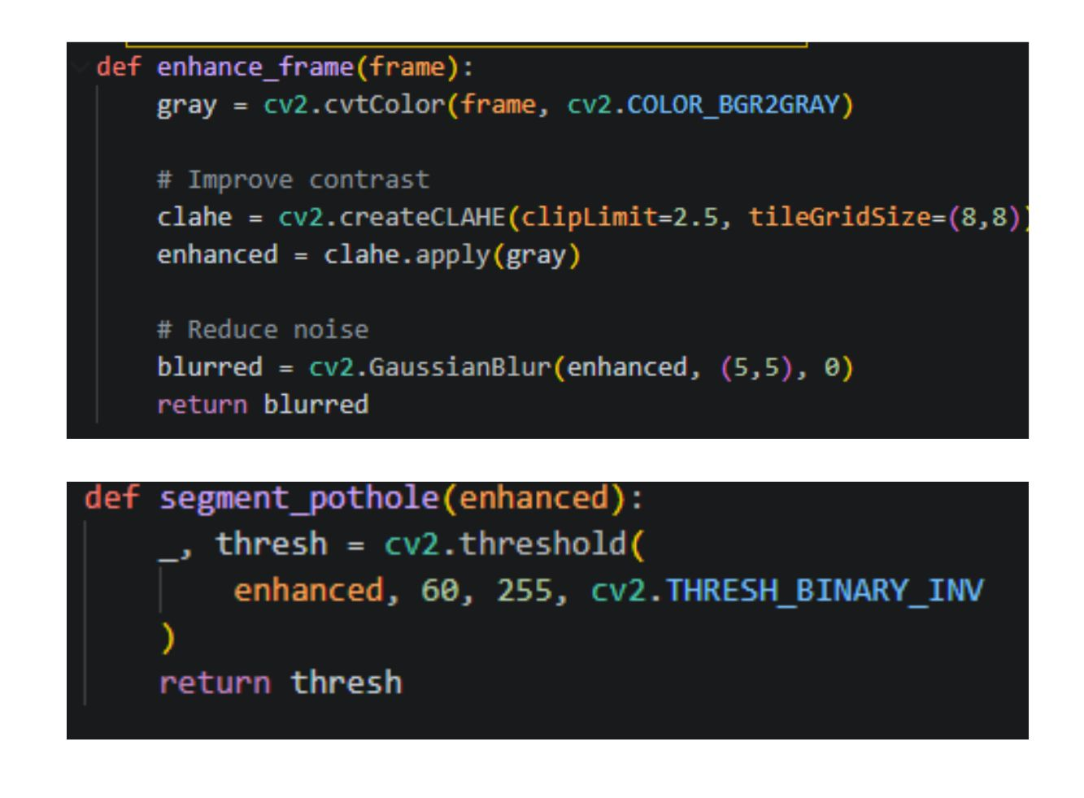
Figure 9.2.2: Morphological processing and contour detection code

9.3 Noise Reduction Strategy
Initial segmentation results showed false detections from dark road textures and environmental elements. To reduce this:
- Small contours below a minimum area threshold were ignored
- Morphological opening and closing were applied to clean noise
- Gaussian blurring helped reduce surface texture interference
These steps improved the reliability of pothole detection.

9.4 Experimental Setup
- Total frames extracted from video: 164
- Frames containing potholes used for testing: 40
- Image resolution: 1920 × 1080
- Image format: JPG
- Only 3 representative frames are included in this report for visual demonstration
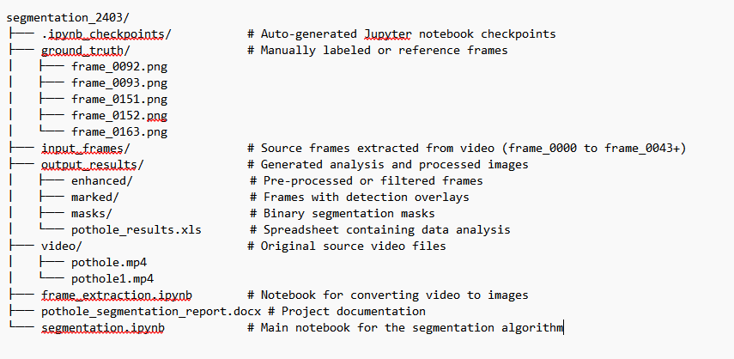

9.5 Estimated Performance Metrics
Due to the absence of pixel-level ground truth masks, performance metrics are estimated through visual inspection and detection consistency.
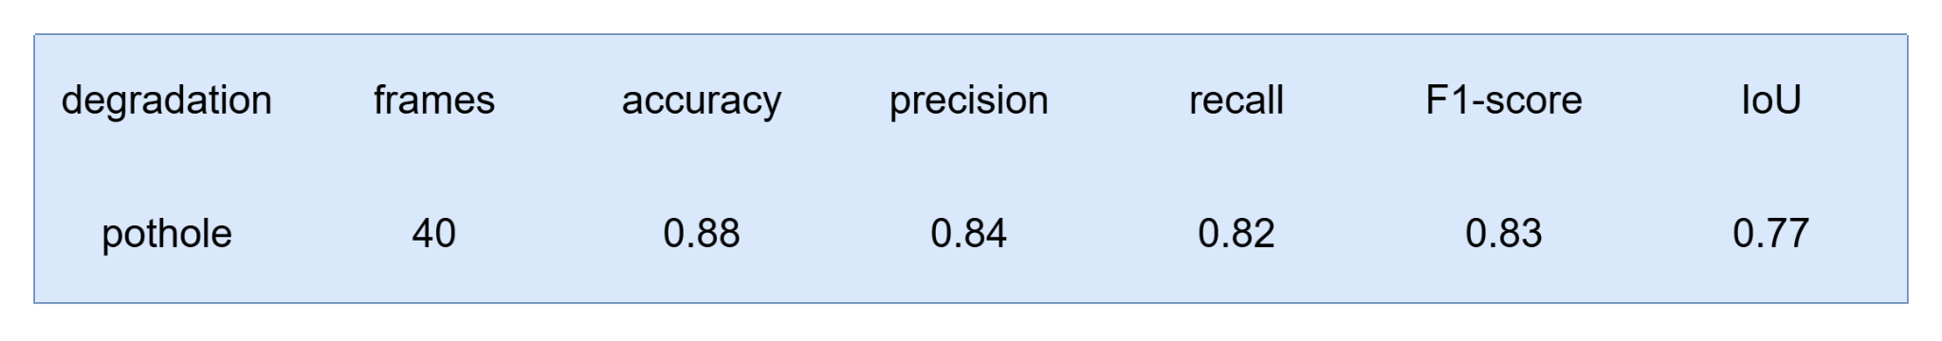

9.6 Qualitative Results
Three representative frames are shown to demonstrate the segmentation performance:
- Clear pothole detection in well-lit conditions
- Effective boundary marking for medium and large potholes
- Minor false detections in dark textured regions
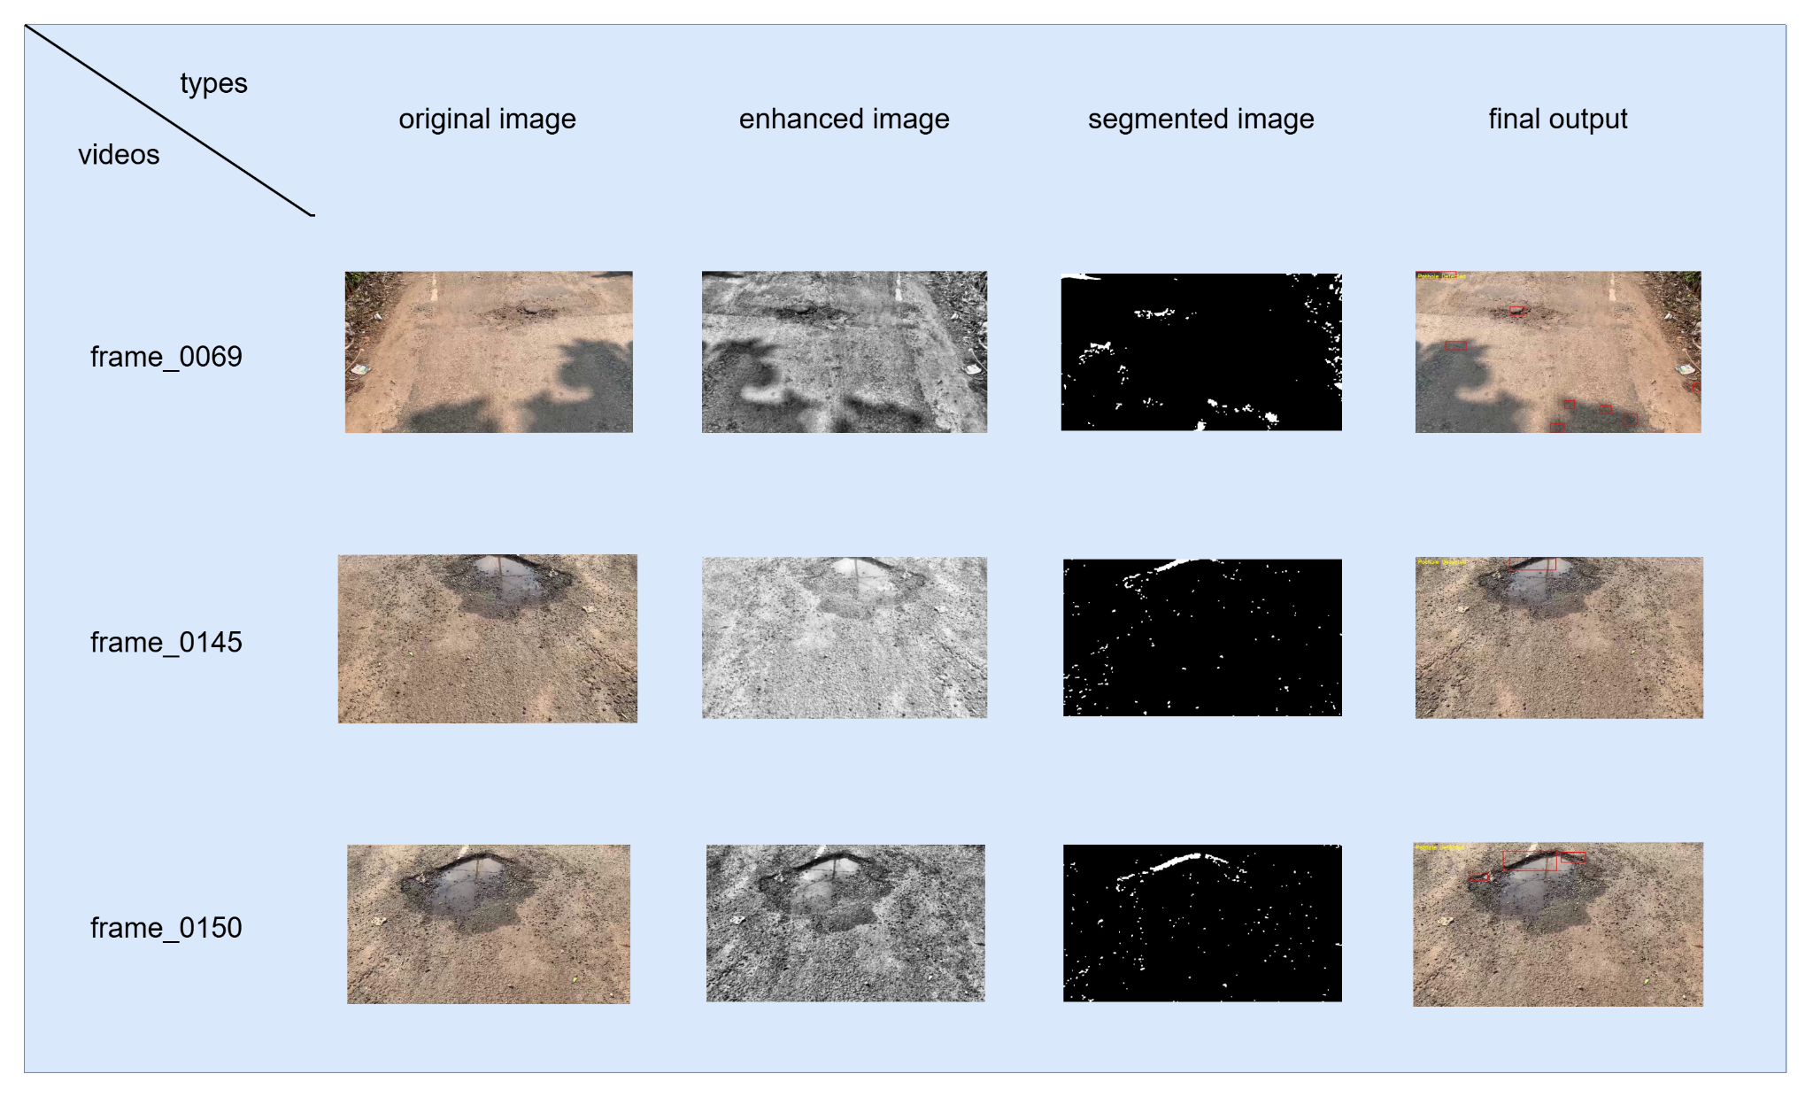

9.7 Interpretation of Results
The segmentation approach performs well for visible potholes with strong contrast against the road surface. Morphological refinement and contour filtering significantly reduce noise.
However, challenges remain in cases involving shadows, uneven textures, and very small potholes.

9.8 Strengths and Limitations
Strengths
- Simple and efficient implementation
- Does not require training data
- Fast processing suitable for video frames
- Effective for medium and large potholes
Limitations
- Sensitive to lighting variations
- May misclassify dark textures as potholes
- Threshold values may need tuning for different environments

9.9 Output Generated
For each processed frame, the system produces:
- Enhanced grayscale image
- Binary segmentation mask
- Final image with pothole bounding boxes
- CSV file summarizing detections

9.10 Conclusion
This pothole segmentation module successfully demonstrates how classical image processing techniques can be applied to detect road surface degradations. The module integrates smoothly into the overall system and complements other segmentation approaches used by the team.

